Aim:

LAB EXPERIMENT-1

Flight Reservation System using Zoho Creator (SaaS)

To create a simple cloud-based Flight Reservation System using Zoho Creator to demonstrate the Software as a Service (SaaS) model with fields such as One Way, Round Trip, From, To, Departure Date, Return Date, Travelers & Class, Fare Type, and Flight Type (Domestic/International).

Software/Tools Required:
- Zoho Creator (Cloud SaaS Platform)
- Web Browser
- Internet Connection

Theory:
Zoho Creator is a cloud-based Low-Code Application Development Platform that allows users to build online applications without extensive programming. In this experiment, a Flight Reservation System is developed using Zoho Creator. The application collects passenger information, stores it in the cloud, and allows users to submit flight booking requests online.

Algorithm:
- Start.
- Log in to Zoho Creator.
- Create a New Application.
- Name the application Flight Reservation System.
- Create a new Form named Flight Reservation.
- Add all required fields.
- Set the appropriate field types (Text, Choice, Date, Dropdown, etc.).
- Save the form.
- Publish or Run the application.
- Enter flight reservation details.
- Click Submit.
- Store the reservation details in Zoho Creator Cloud Database.
- Display the submitted record.

- Stop.

Form Fields:

Field Name | Field Type
Passenger Name | Single Line
Email Address | Email
Mobile Number | Phone Number
Flight Type | Radio Button (One Way, Round Trip)
From | Dropdown
To | Dropdown
Departure Date | Date
Return Date | Date
Travelers | Number
Travel Class | Dropdown (Economy, Premium Economy, Business, First Class)
Fare Type | Dropdown (Regular, Student, Senior Citizen)
Flight Category | Radio Button (Domestic, International)
Special Request | Multi-Line

Procedure:
- Open Zoho Creator.
- Click Create New Application.
- Enter the application name as Flight Reservation System.
- Create a new form called Flight Reservation.
- Add all the required fields.
- Configure field properties.
- Save the form.
- Click Access This Application.
- Enter reservation details.

- Submit the form.
- Verify that the data is stored in the report.

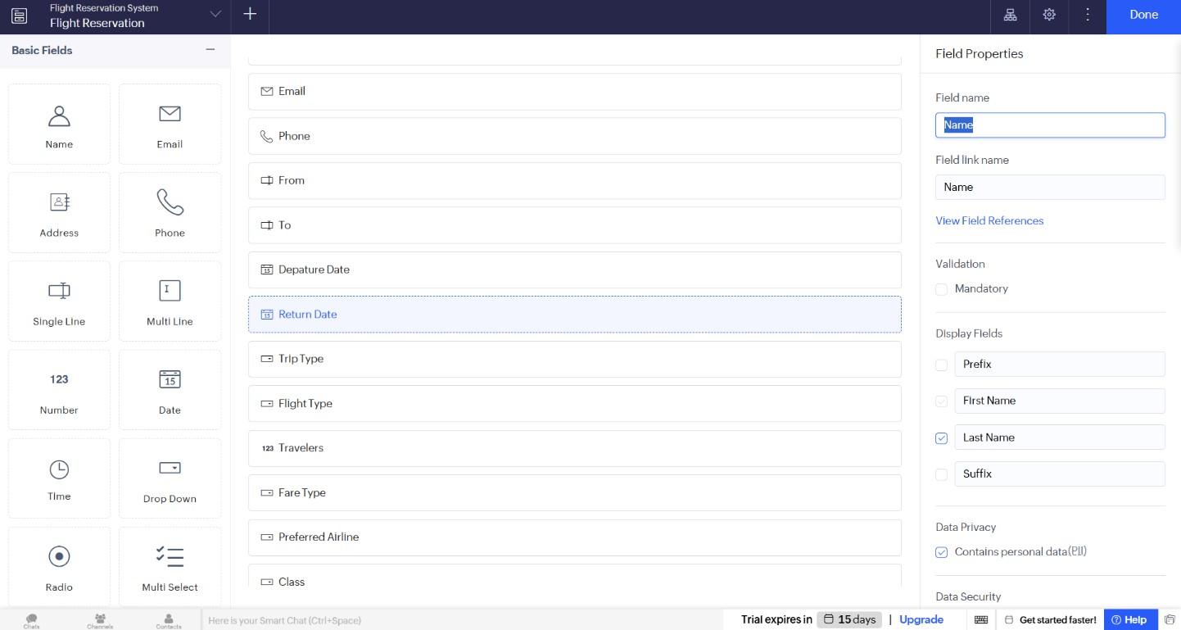
OUTPUT SCREENSHOTS:

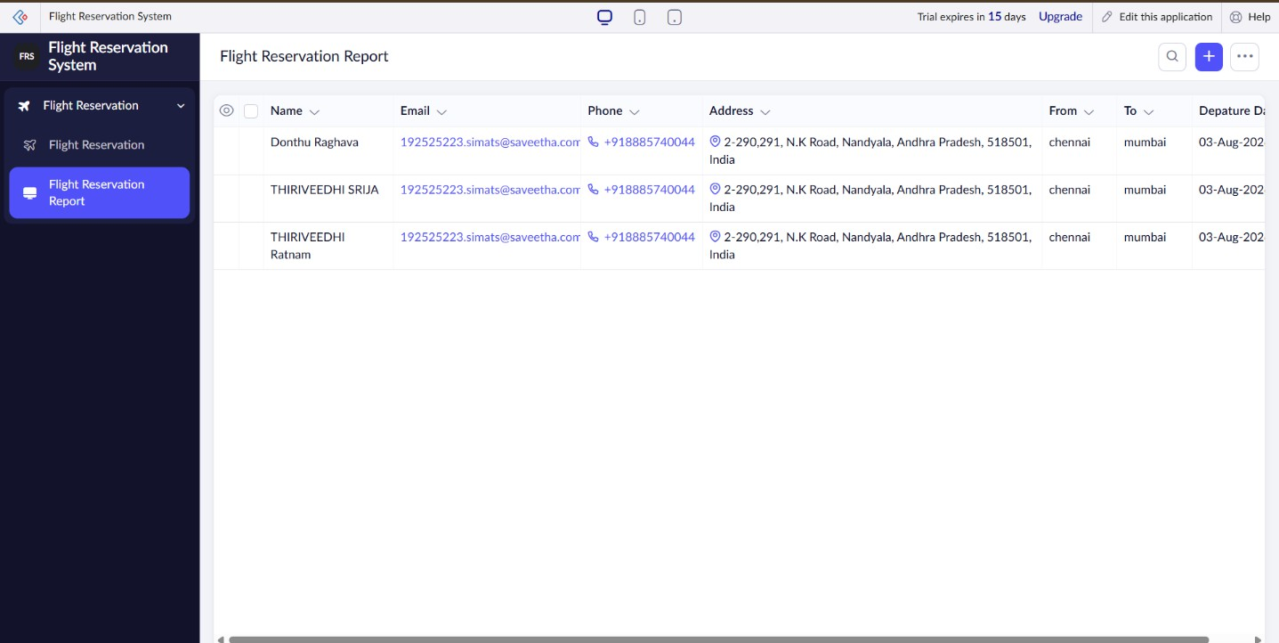

Result: Thus, a cloud-based Flight Reservation System was successfully created using Zoho Creator. The application demonstrates the Software as a Service (SaaS) model by collecting and storing reservation details securely in the cloud.

Experiment No.:2
Property Buying & Rental System (Chennai City) using Zoho Creator (SaaS)

Aim:
To create a simple cloud-based Property Buying & Rental System for Chennai city using Zoho Creator to demonstrate the Software as a Service (SaaS) model with fields such as Buy, Rent, Commercial, Rental Agreement, Area, Place, Budget Range, Property Value, and other necessary details.

Software/Tools Required:
- Zoho Creator (Cloud SaaS Platform)
- Web Browser
- Internet Connection

Theory:
Software as a Service (SaaS) is a cloud computing model in which software applications are accessed through the internet without local installation. Zoho Creator is a low-code cloud platform that enables users to build web applications quickly. In this experiment, a Property Buying & Rental System is developed to collect and store customer property requirements securely in the cloud.

Algorithm
- Start.
- Log in to Zoho Creator.
- Create a New Application.
- Name the application Property Buying & Rental System.
- Create a new Property Registration Form.
- Add all required fields.
- Assign suitable field types (Text, Dropdown, Date, Currency, etc.).
- Save the form.
- Run the application.
- Enter customer and property details.
- Click Submit.

- Store the information in the Zoho Creator cloud database.
- Display the submitted record.
- Stop.

Form Fields:

Field Name | Zoho Creator Field Type
Customer Name | Single Line
Email Address | Email
Mobile Number | Phone
Property Type | Radio (Buy, Rent)
Property Category | Dropdown (Residential, Commercial)
Rental Agreement | Radio (Yes, No)
Area (sq.ft) | Number
Place (Chennai Locations) | Dropdown
Budget Range | Dropdown
Property Value | Currency
Number of Bedrooms | Number
Address | Multi Line
Preferred Possession Date | Date
Additional Requirements | Multi Line

Procedure:
- Open Zoho Creator.
- Create a new application.
- Name it Property Buying & Rental System.
- Create a form named Property Registration.
- Add all the required fields.
- Configure the appropriate field types.

- Save the form.
- Run the application.
- Enter the customer and property details.
- Click Submit.
- Verify the submitted data in the generated report.

OUTPUT SCREEN SHOTS:
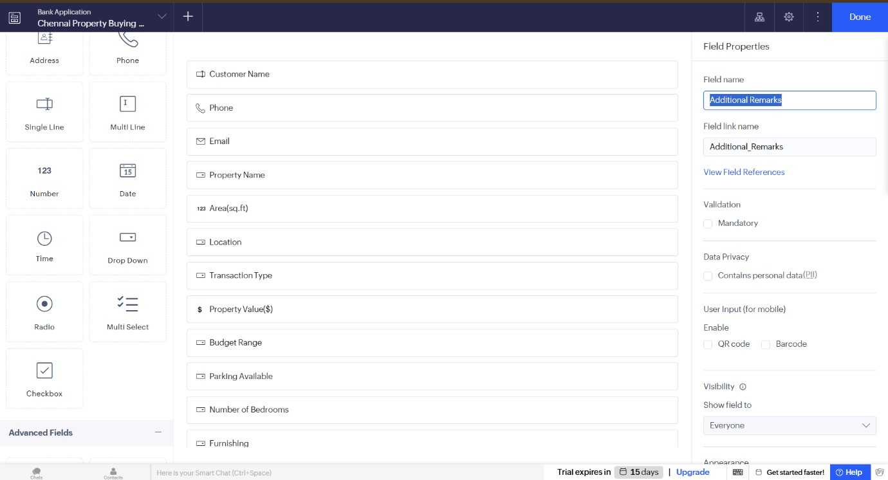

Result:
Thus, a cloud-based Property Buying & Rental System was successfully created using Zoho Creator. The application demonstrates the Software as a Service (SaaS) model by allowing users to submit and store property buying and rental details securely in the cloud.

Aim:
Experiment No.:3
Car Booking Reservation System using Zoho Creator (SaaS)

To create a simple cloud-based Car Booking Reservation System using Zoho Creator to demonstrate the Software as a Service (SaaS) model with fields such as Search for Cabs, From, To, Rental, Outstation, Package Type, Hours/Days, and other booking details.

Software/Tools Required:
- Zoho Creator (Cloud SaaS Platform)
- Web Browser
- Internet Connection

Theory:
Software as a Service (SaaS) is a cloud computing model that enables users to access software applications through the internet without installing them locally. Zoho Creator is a low-code cloud platform used to develop online applications. In this experiment, a Car Booking Reservation System is created to allow users to reserve cabs online, and the booking information is stored securely in the cloud.

Algorithm:
- Start.
- Log in to Zoho Creator.
- Create a New Application.
- Name the application Car Booking Reservation System.
- Create a new Car Booking Form.
- Add all the required fields.
- Assign suitable field types (Text, Dropdown, Date, Number, etc.).
- Save the form.
- Run the application.
- Enter the booking details.
- Click Submit.
- Store the booking information in the Zoho Creator cloud database.
- Display the submitted booking record.

- Stop.

Form Fields:

Field Name | Zoho Creator Field Type
Customer Name | Single Line
Email Address | Email
Mobile Number | Phone
Search for Cabs | Dropdown
Trip Type | Radio (Rental, Outstation)
From | Single Line
To | Single Line
Pickup Date | Date
Pickup Time | Time
Package Type | Dropdown
Hours/Days | Number
Number of Passengers | Number
Payment Method | Dropdown
Special Instructions | Multi Line

Procedure:
- Open Zoho Creator.
- Create a new application.
- Name it Car Booking Reservation System.
- Create a form named Car Booking Form.
- Add all the required fields.
- Configure the appropriate field types.
- Save the form.
- Run the application.
- Enter the booking details.
- Click Submit.

- Verify the submitted booking details in the generated report.

OUTPUT SCREENSHOTS:
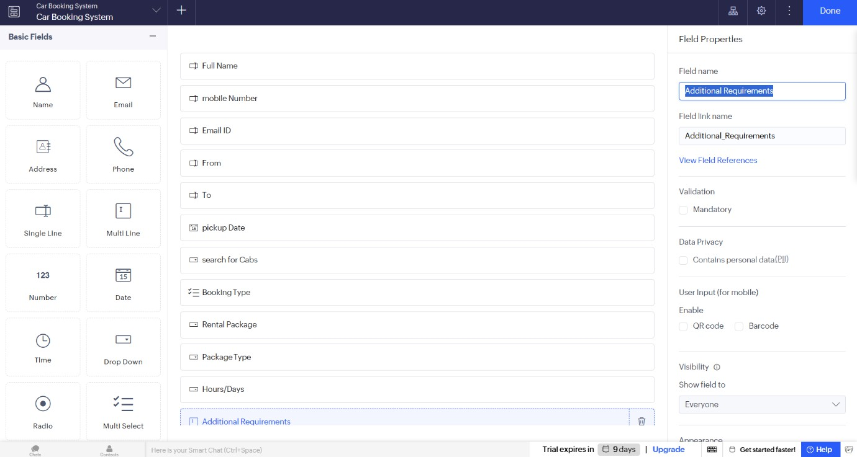
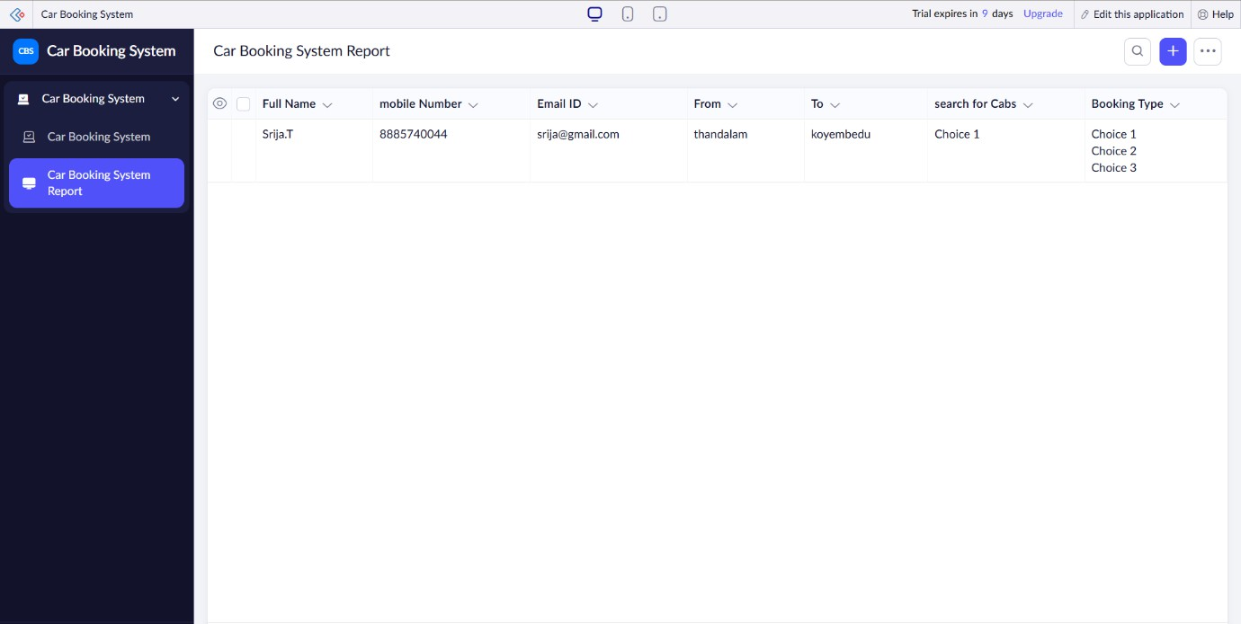

Result:
Thus, a cloud-based Car Booking Reservation System was successfully created using Zoho Creator. The application demonstrates the Software as a Service (SaaS) model by allowing users to reserve cabs online and storing booking information securely in the cloud.

Experiment No.:4
Library Book Reservation System for SIMATS Library using Zoho Creator (SaaS)
Aim:
To create a simple cloud-based Library Book Reservation System for SIMATS Library using Zoho Creator to demonstrate the Software as a Service (SaaS) model with fields such as Book Title, Author, Publication, Year, Edition, Number of Copies, Rack Number, and Book Status (Taken/Returned).

Software/Tools Required:
- Zoho Creator (Cloud SaaS Platform)
- Web Browser
- Internet Connection

Theory:
Software as a Service (SaaS) is a cloud computing model in which applications are accessed over the internet without installing software on individual computers. Zoho Creator is a
low-code cloud platform that enables users to develop web-based applications quickly. In this experiment, a Library Book Reservation System is developed to manage book reservations and maintain book records securely in the cloud.

Algorithm:
- Start.
- Log in to Zoho Creator.
- Create a New Application.
- Name the application SIMATS Library Book Reservation System.
- Create a new Library Book Reservation Form.
- Add all the required fields.
- Assign suitable field types (Text, Number, Date, Dropdown, etc.).
- Save the form.
- Run the application.
- Enter the library book details.
- Click Submit.
- Store the reservation details in the Zoho Creator cloud database.

- Display the submitted record.
- Stop.

Form Fields:

Field Name | Zoho Creator Field Type
Student Name | Single Line
Registration Number | Single Line
Department | Dropdown
Email Address | Email
Mobile Number | Phone
Book Title | Single Line
Author | Single Line
Publication | Single Line
Publication Year | Number
Edition | Single Line
Number of Copies | Number
Rack Number | Single Line
Book Status | Radio (Taken, Returned)
Reservation Date | Date
Return Date | Date
Remarks | Multi Line

Procedure:
- Open Zoho Creator.
- Create a new application.

Name it SIMATS Library Book Reservation System.
- Create a form named Library Book Reservation Form.
- Add all the required fields.
- Configure the appropriate field types.
- Save the form.

- Run the application.
- Enter the library book details.
- Click Submit.
- Verify the submitted data in the generated report.

OUTPUT SCREENSHOTS:
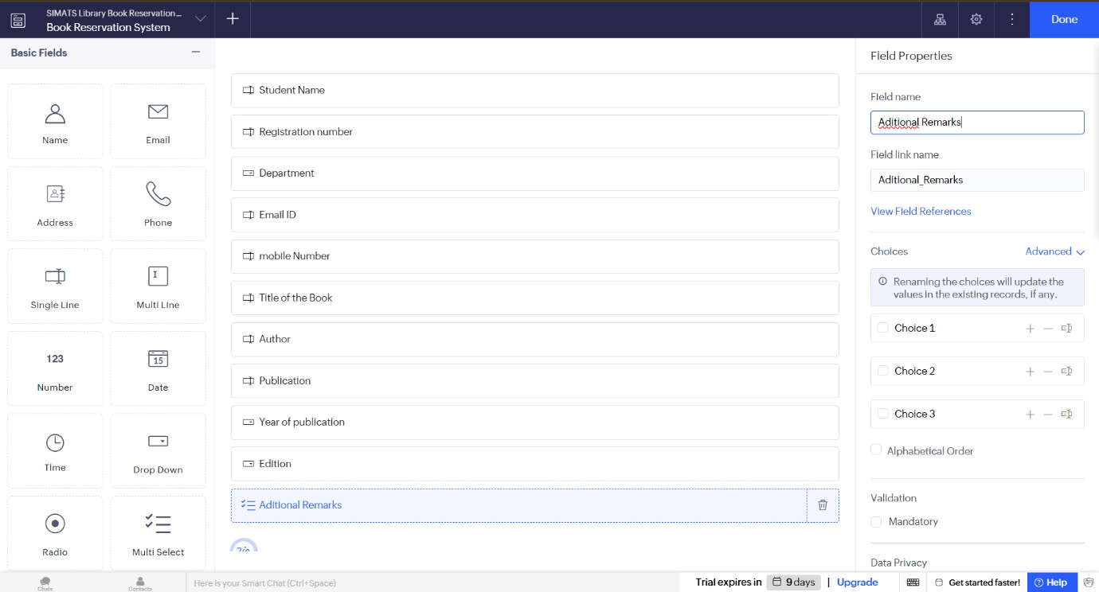
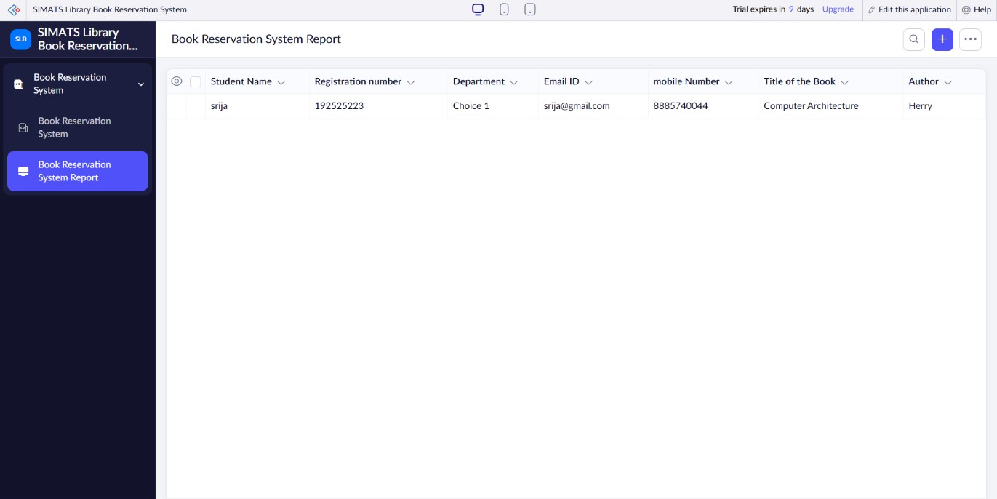

Result: Thus, a cloud-based Library Book Reservation System for SIMATS Library was successfully created using Zoho Creator. The application demonstrates the Software as a Service (SaaS) mode.

Aim:
Experiment No.:5
Mark Sheet Processing System using Zoho Creator (SaaS)

To create a simple cloud-based Mark Sheet Processing System using Zoho Creator to demonstrate the Software as a Service (SaaS) model with fields such as Student Name, Registration Number, Subjects, Marks, Average, Percentage, Rank, and Overall Performance.

Software/Tools Required:
- Zoho Creator (Cloud SaaS Platform)
- Web Browser
- Internet Connection

Theory:
Software as a Service (SaaS) is a cloud computing model in which applications are hosted on the cloud and accessed through the internet. Zoho Creator is a low-code cloud platform that enables users to create online applications without extensive programming. In this experiment, a Mark Sheet Processing System is developed to store students' academic records, calculate averages and percentages, assign ranks, and display the overall performance.

Algorithm:
- Start.
- Log in to Zoho Creator.
- Create a New Application.
- Name the application Mark Sheet Processing System.
- Create a new Student Mark Sheet Form.
- Add all the required fields.
- Enter the student's details and subject marks.
- Calculate the Total Marks.
- Calculate the Average Marks.
- Calculate the Percentage.
- Assign the Rank.
- Determine the Overall Performance based on the percentage.
- Save and submit the form.

- Store the details in the Zoho Creator cloud database.
- Display the processed mark sheet.
- Stop.

Form Fields:

Field Name | Zoho Creator Field Type
Student Name | Single Line
Register Number | Single Line
Department | Dropdown
Semester | Dropdown
Subject 1 | Single Line
Marks 1 | Number
Subject 2 | Single Line
Marks 2 | Number
Subject 3 | Single Line
Marks 3 | Number
Subject 4 | Single Line
Marks 4 | Number
Subject 5 | Single Line
Marks 5 | Number
Total Marks | Formula/Number
Average | Formula/Decimal
Percentage | Formula/Decimal
Rank | Number
Overall Performance | Dropdown/Formula
Remarks | Multi Line

Procedure:

- Open Zoho Creator.
- Create a new application.
- Name it Mark Sheet Processing System.
- Create a form named Student Mark Sheet.
- Add all the required fields.
- Configure appropriate field types.
- Create formula fields for Total Marks, Average, and Percentage.
- Save the form.
- Run the application.
- Enter the student's details and marks.
- Click Submit.
- Verify the processed mark sheet in the generated report.

OUTPUT SCREENSHOTS:
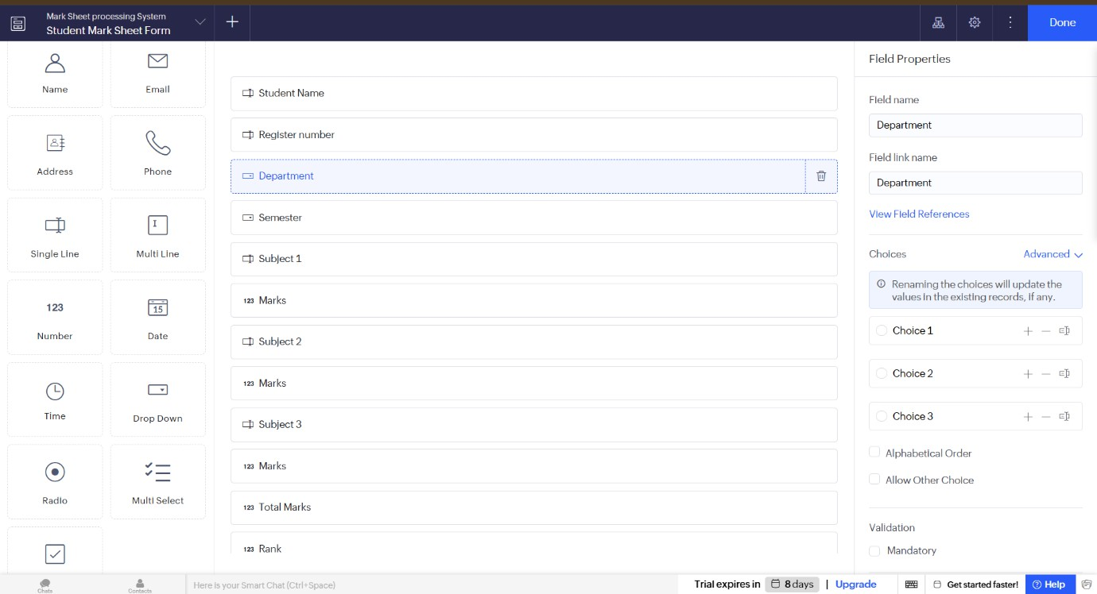

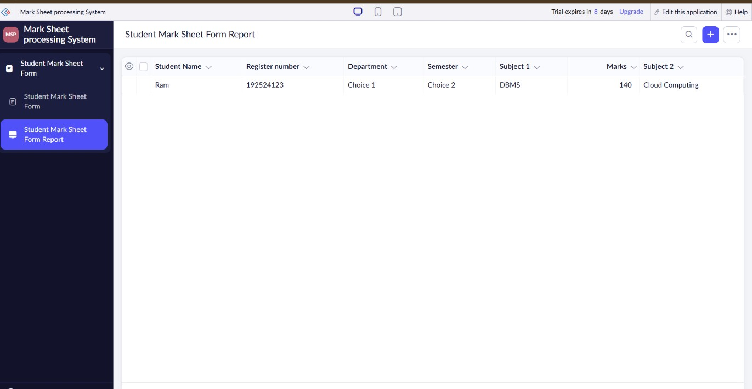

Result:
Thus, a cloud-based Mark Sheet Processing System was successfully created using Zoho Creator. The application demonstrates the Software as a Service (SaaS) model by storing student records, calculating marks, averages, percentages, ranks, and displaying the overall performance securely in the cloud.

Aim:
Experiment No.:6
Payroll Processing System using Zoho Creator (SaaS)

To create a simple cloud-based Payroll Processing System using Zoho Creator to demonstrate the Software as a Service (SaaS) model with fields such as Employee Name, Experience in Present Organization, Overall Experience, Basic Pay, HRA, DA, TA, Gross Pay, and Net Pay.

Software/Tools Required:
- Zoho Creator (Cloud SaaS Platform)
- Web Browser
- Internet Connection

Theory:
Software as a Service (SaaS) is a cloud computing model in which software applications are hosted on the cloud and accessed through the internet. Zoho Creator is a low-code cloud platform used to create business applications without extensive programming. In this experiment, a Payroll Processing System is developed to manage employee salary details, calculate gross pay and net pay, and securely store payroll records in the cloud.

Algorithm:
- Start.
- Log in to Zoho Creator.
- Create a New Application.
- Name the application Payroll Processing System.
- Create a new Employee Payroll Form.
- Add all the required fields.
- Enter the employee details and salary components.
- Calculate Gross Pay by adding Basic Pay, HRA, DA, and TA.
- Calculate Net Pay after applicable deductions (if any).
- Save and submit the form.
- Store the payroll details in the Zoho Creator cloud database.
- Display the employee payroll record.
- Stop.

Form Fields:

Field Name | Zoho Creator Field Type
Employee ID | Single Line
Employee Name | Single Line
Department | Dropdown
Designation | Single Line
Experience in Present Organization (Years) | Number
Overall Experience (Years) | Number
Basic Pay | Currency
HRA | Currency
DA | Currency
TA | Currency
Other Allowances | Currency
Gross Pay | Formula/Currency
Deductions | Currency
Net Pay | Formula/Currency
Payment Month | Dropdown
Remarks | Multi Line

Procedure:
- Open Zoho Creator.
- Create a new application.
- Name it Payroll Processing System.
- Create a form named Employee Payroll Form.
- Add all the required fields.
- Configure field types.
- Create formula fields:
  - Gross Pay = Basic Pay + HRA + DA + TA + Other Allowances

  - Net Pay = Gross Pay − Deductions
- Save the form.
- Run the application.
- Enter employee and salary details.
- Click Submit.
- Verify the payroll record in the generated report.

OUTPUT SCREENSHOTS:
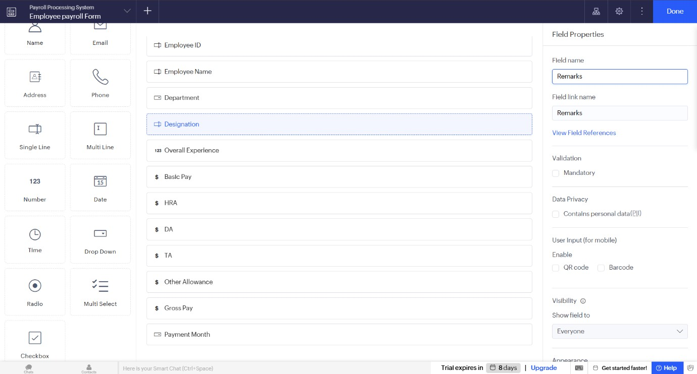
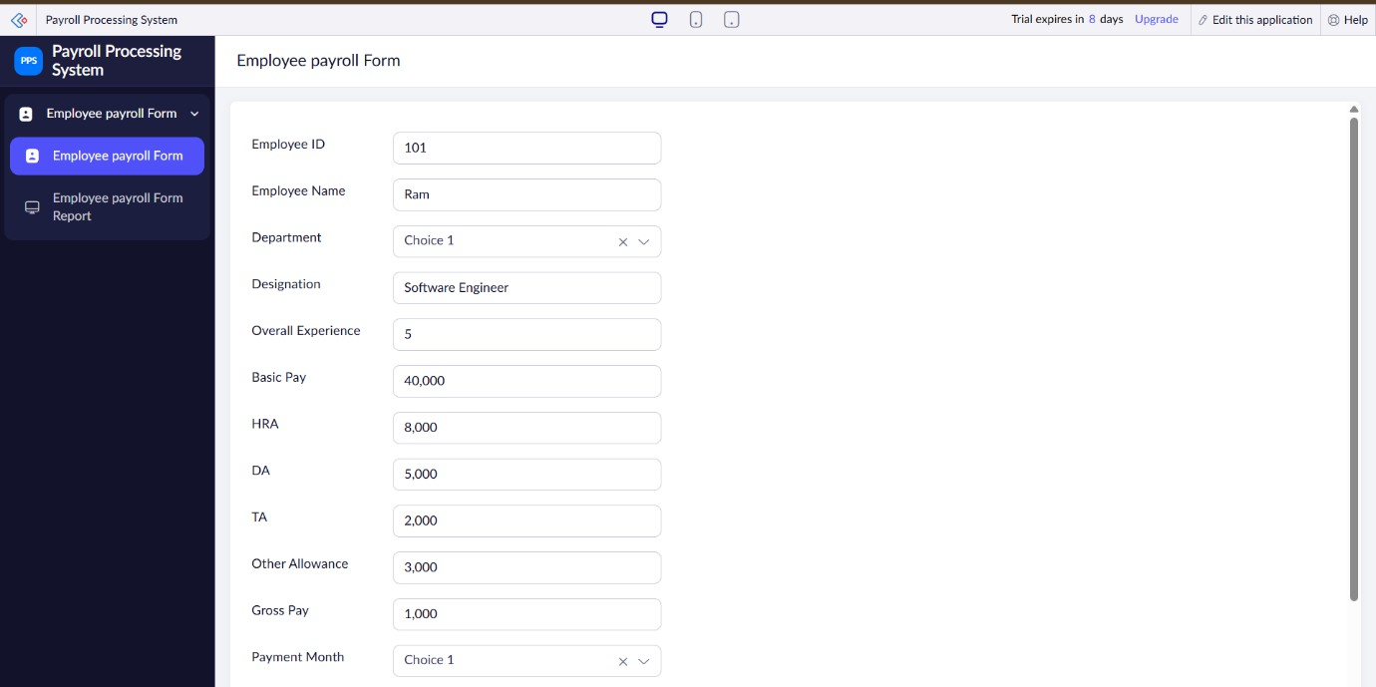

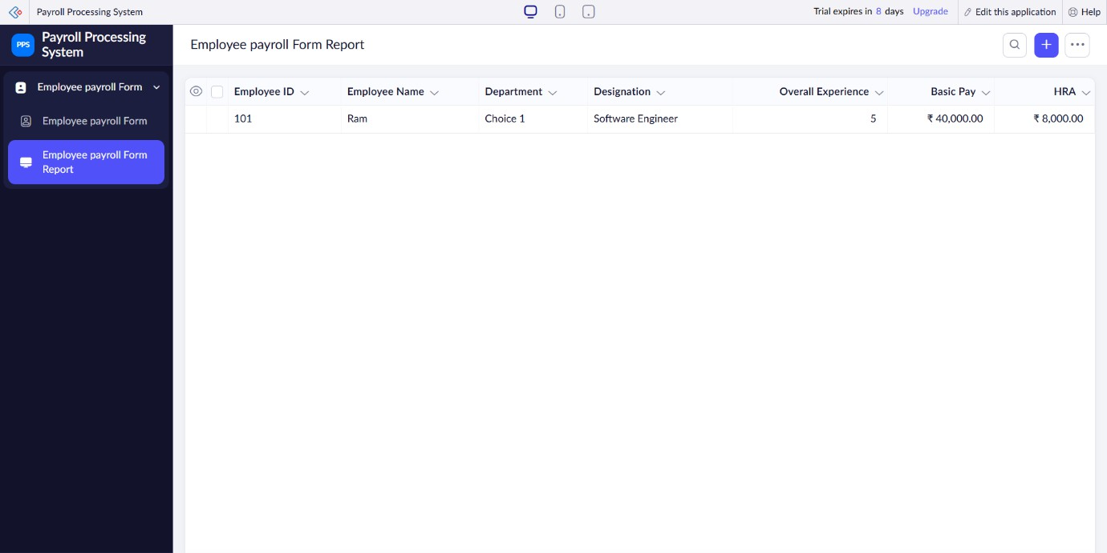

Result:
Thus, a cloud-based Payroll Processing System was successfully created using Zoho Creator. The application demonstrates the Software as a Service (SaaS) model by calculating employee salaries, gross pay, net pay, and securely storing payroll records in the cloud.

Aim:

LAB EXPERIMENT-6

Create a Simple Cloud Software Application for Students Attendance System using Zoho Creator (SaaS)

To create a cloud-based Students Attendance System using Zoho Creator to demonstrate the Software as a Service (SaaS) model.

Software/Tools Required
- Zoho Creator
- Web Browser
- Internet Connection

Procedure:
Step 1: Login
- Open Zoho Creator.
- Sign in with your Zoho account.

Step 2: Create Application:
- Click Create Application.
- Select Blank Application.
- Enter the application name as Students Attendance System. Step 3: Create Form:
Create a form named Student Attendance and add the following fields:

Field Name | Data Type
Student Name | Single Line
Register Number | Number
Course | Dropdown
Total Classes | Number
Present | Number
Absent | Formula
Attendance Percentage | Formula

Field Name Data Type

OD Request | Checkbox
Grade | Formula

Formula Expressions:
Absent
Total Classes - Present

Attendance Percentage:
(Present / Total Classes) * 100

Grade:
If (Attendance_Percentage >= 90,"A", if( Attendance_Percentage >=80,"B", if (Attendance_Percentage >=70,"C",
if (Attendance_Percentage >=60,"D","F"))))

OUTPUT SCREENSHOTS:
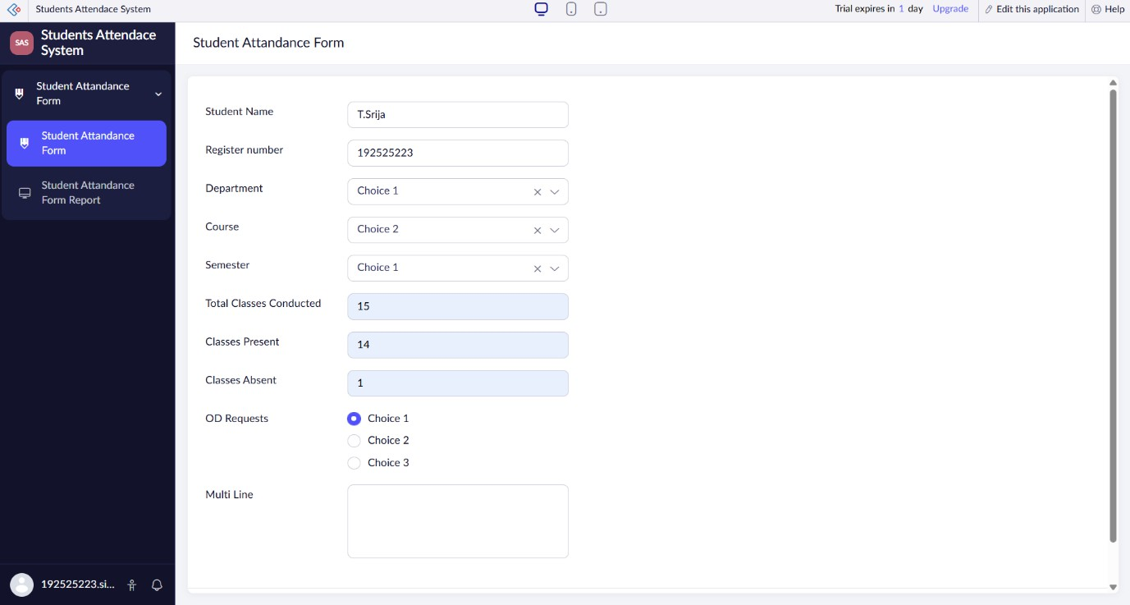

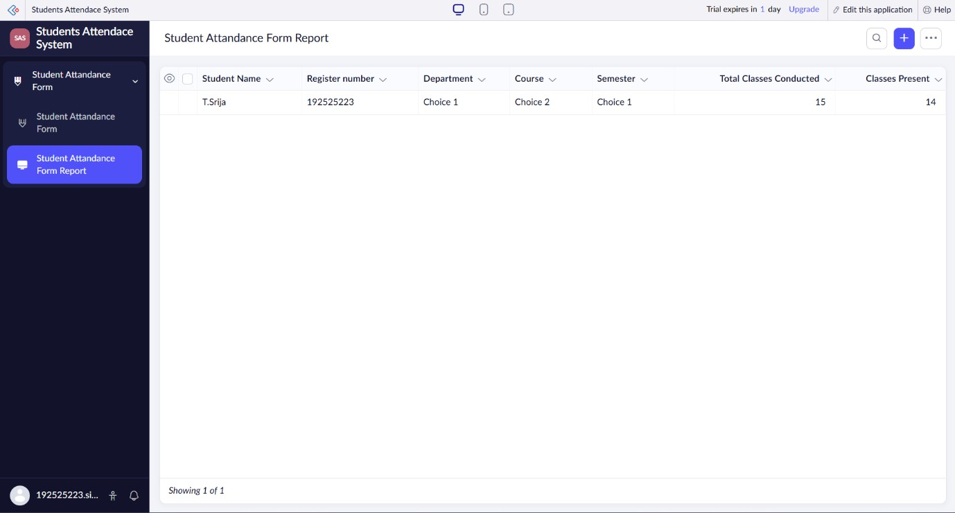

Result:
The Students Attendance System was successfully created using Zoho Creator as a SaaS application. The system stores attendance records, calculates attendance percentage, manages OD requests, assigns grades automatically, and provides a dashboard for monitoring student attendance.

LAB EXPERIMENT-8

Create a Simple Cloud Web Application for Student Counselling System using Zoho Creator (SaaS)

Aim:
To create a cloud-based Student Counselling System using Zoho Creator to demonstrate the Software as a Service (SaaS) model.

Software/Tools Required:
- Zoho Creator
- Web Browser
- Internet Connection

Procedure:
Step 1: Login
- Open Zoho Creator.
- Sign in with your Zoho account. Step 2: Create Application:
- Click Create Application.
- Select Blank Application.
- Enter the application name as Student Counselling System. Step 3: Create Form:

Create a form named Student Details and add the following fields:

Field Name | Data Type
Student Name | Single Line
Age | Number
Gender | Dropdown
Address | Multi Line
Phone Number | Phone
Email | Email
Subjects Studied | Multi Line

Field Name Data Type

Year of Passing | Number
Percentage of Marks | Decimal
Domain Interest | Dropdown
Counselling Status | Dropdown
Remarks | Multi Line

Formula Expressions:
Eligibility Status:
if(Percentage_of_Marks >= 60,"Eligible","Not Eligible") Counselling Recommendation:
if(Percentage_of_Marks >= 85,"Advanced Course", if(Percentage_of_Marks >=70,"Professional Course", "Foundation Course"))

OUTPUT SCREENSHOTS:
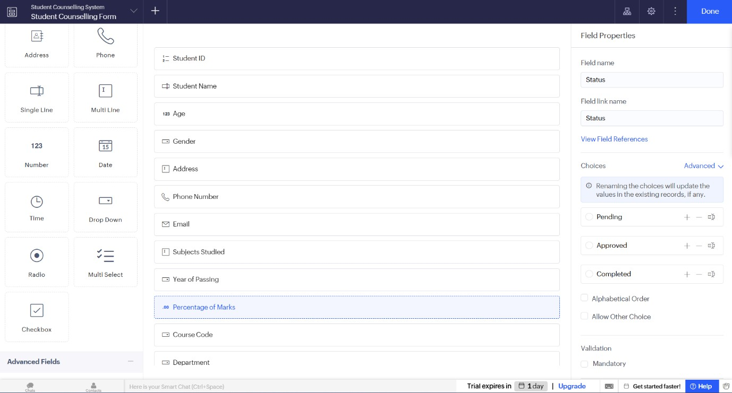

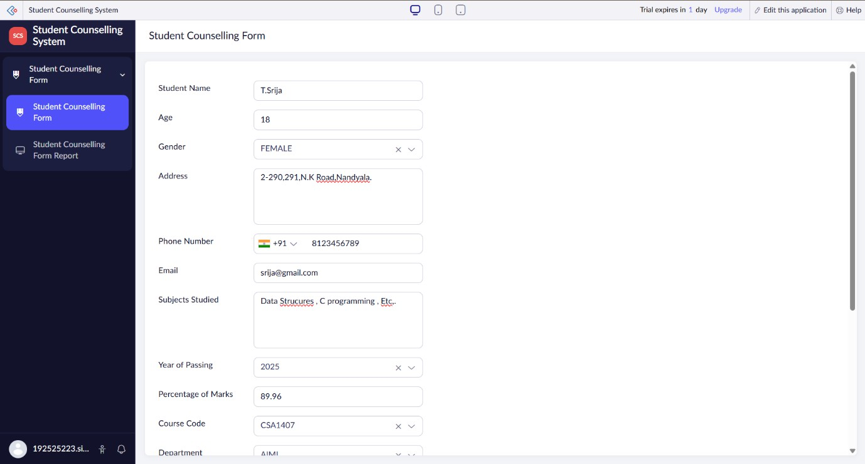

Result:
The Student Counselling System was successfully created using Zoho Creator as a SaaS application. The system stores student details, evaluates eligibility, recommends suitable counselling courses, and provides a dashboard for easy monitoring of student information.

Aim:

LAB EXPERIMENT-9

Create a Simple Cloud Software Application for SIMATS Hospital Information System using Zoho Creator (SaaS)

To create a cloud-based Hospital Information System for SIMATS Hospital using Zoho Creator to demonstrate the Software as a Service (SaaS) model.

Software/Tools Required:
- Zoho Creator
- Web Browser
- Internet Connection

Procedure:
Step 1: Login
- Open Zoho Creator.
- Sign in with your Zoho account.

Step 2: Create Application
- Click Create Application.
- Select Blank Application.
- Enter the application name as SIMATS Hospital Information System. Step 3: Create Form
Create a form named Patient Information and add the following fields:

Field Name | Data Type
Patient Name | Single Line
Age | Number
Gender | Dropdown
Address | Multi Line
Phone Number | Phone
Email | Email
Attender Name | Single Line

Field Name Data Type

Attender Phone | Phone
Doctor Name | Dropdown
Disease | Multi Line
Date of Admission | Date
Room Type | Dropdown
Consultation Fee | Currency
Treatment Status | Dropdown

Formula Expressions:
Patient Category
if(Age >= 60,"Senior Citizen", if(Age >=18,"Adult","Child")) Treatment Status:
if(Disease != "","Under Treatment","Pending")

OUTPUT SCREENSHOTS:
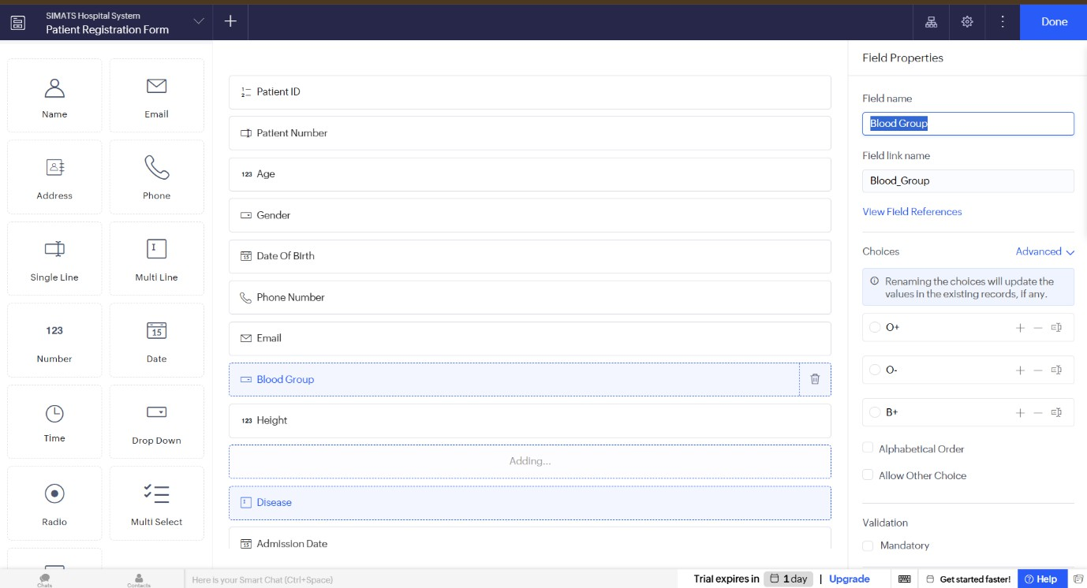

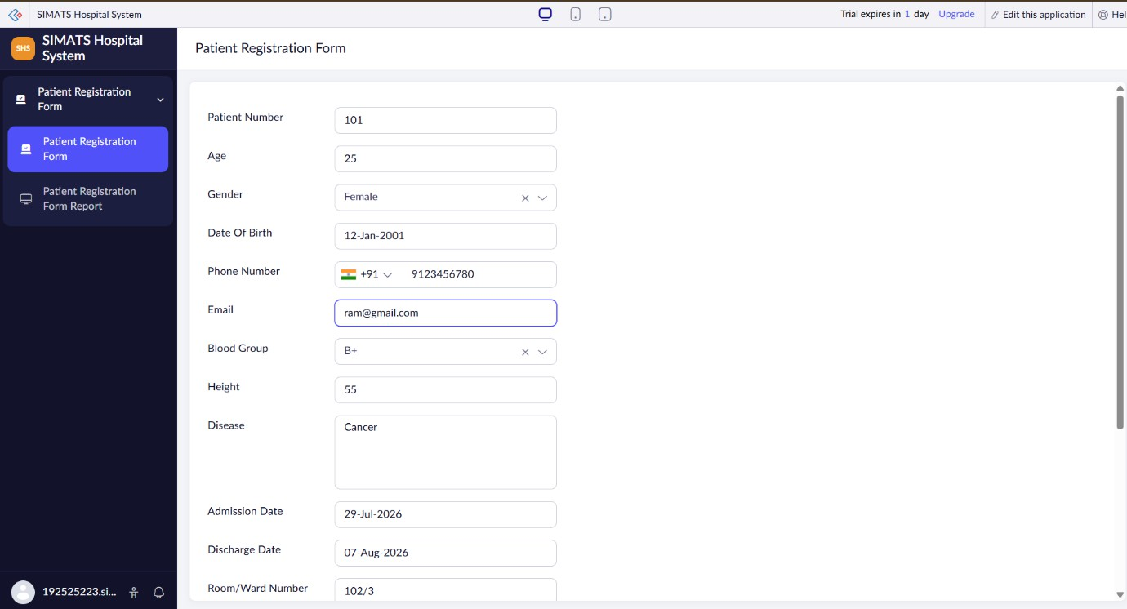
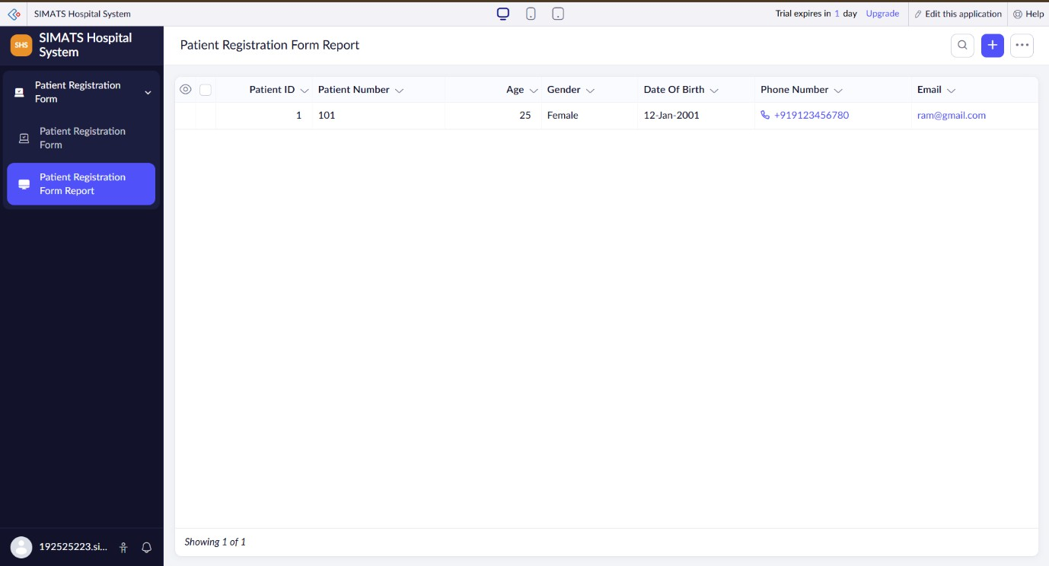

Result:
The SIMATS Hospital Information System was successfully created using Zoho Creator as a SaaS application. The system stores patient records, manages doctor and treatment details, and provides a dashboard for monitoring hospital information efficiently.

LAB EXPERIMENT-10

Create a Simple Cloud Software Application to Run a C Program to Display Student Information Using a Cloud Service Provider (SaaS)

Aim:
To create a simple cloud-based Student Information Management System using Zoho Creator to demonstrate Software as a Service (SaaS) with student details, grades, attendance report, progress report, semester mark sheet, and a C program to display student information.

Software/Tools Required:
- Zoho Creator
- Web Browser (Google Chrome/Microsoft Edge)
- Internet Connection
- C Programming Language (Turbo C/GCC/Online Compiler)

Procedure:
- Log in to Zoho Creator.
- Click Create New Application.
- Name the application Student Information Management System.
- Create the Student Registration form.
- Add the required fields.
- Create the Grades form.
- Create the Attendance Report form.
- Create the Progress Report form.
- Create the Semester Mark Sheet form.
- Create the C Program form.
- Create reports for each form.
- Create a dashboard displaying student details and reports.
- Save and run the application.

Student Registration Form:

Field | Data Type
Student Name | Single Line
Register Number | Single Line
Address | Multi Line
Phone Number | Phone
Age | Number
Course | Drop Down
Semester | Drop Down

Grades Form:

Field | Data Type
Register Number | Lookup
Student Name | Lookup
Subject | Drop Down
Grade | Drop Down

Attendance Report Form:

Field | Data Type
Register Number | Lookup
Student Name | Lookup
Total Classes | Number
Attended Classes | Number
Attendance Percentage | Formula

Formula
(input.Attended_Classes/input.Total_Classes)*100

Progress Report Form:

Field | Data Type
Register Number | Lookup
Student Name | Lookup
Internal Marks | Number
Assignment Marks | Number
Remarks | Multi Line

Semester Mark Sheet Form:

Field | Data Type
Register Number | Lookup
Student Name | Lookup
Semester | Drop Down
Total Marks | Number
Percentage | Formula
Result | Drop Down
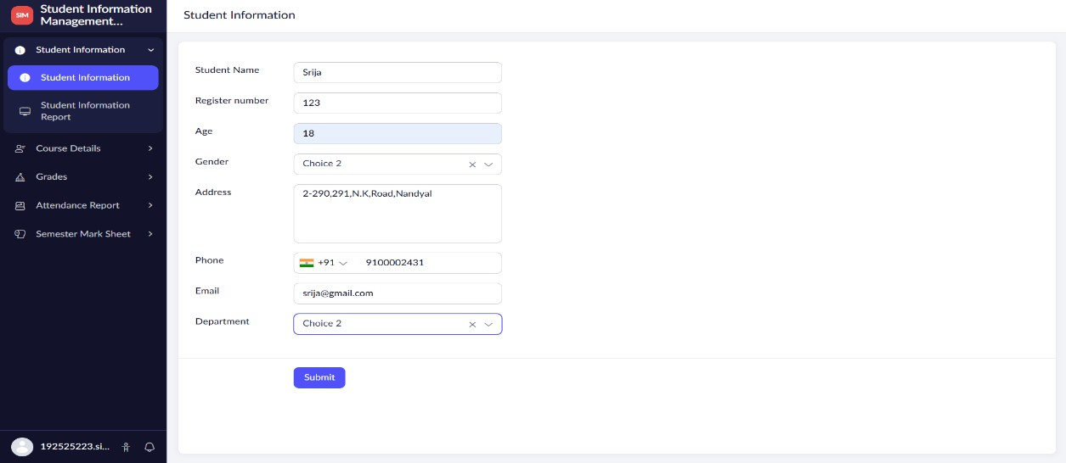
Formula (input.Total_Marks/500)*100 OUTPUT SCREENSHOTS:

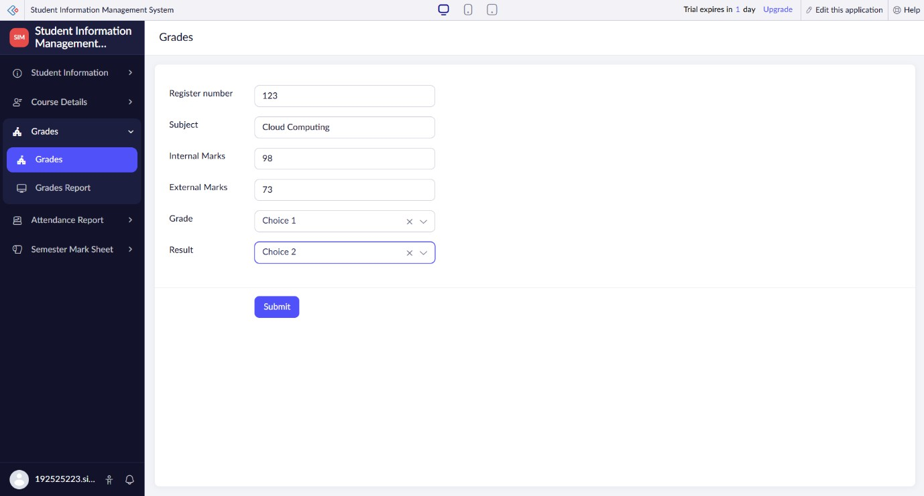

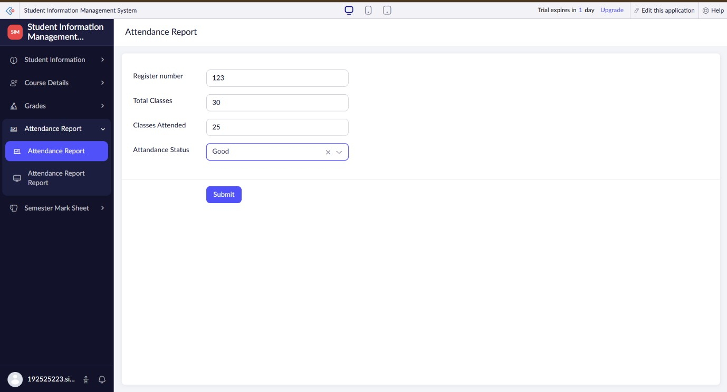

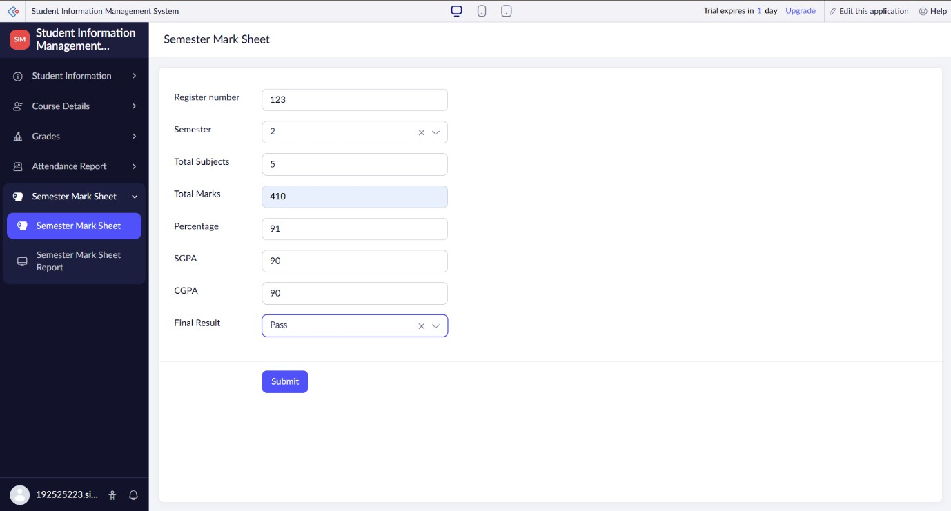

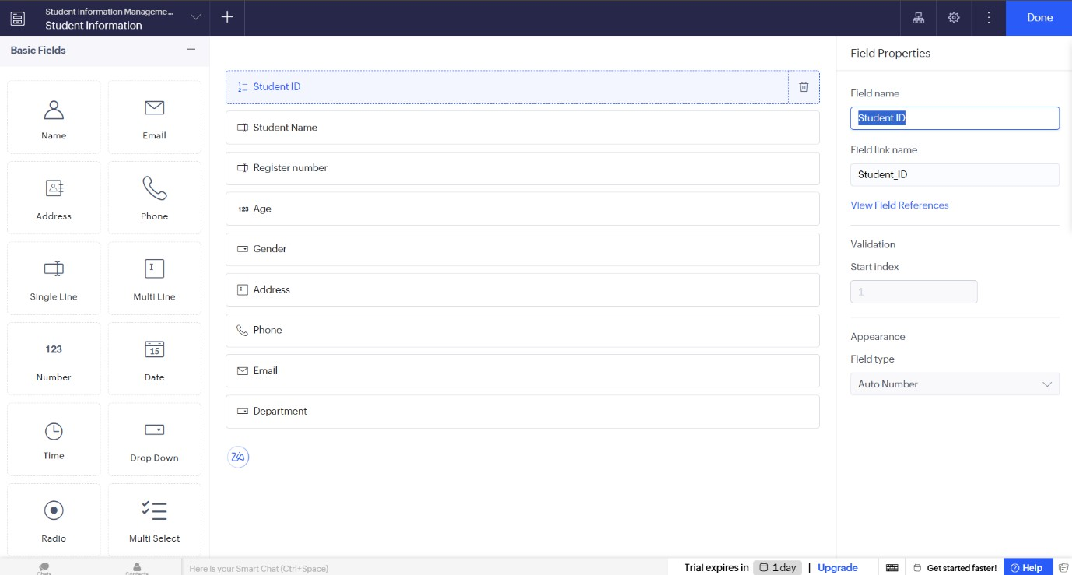

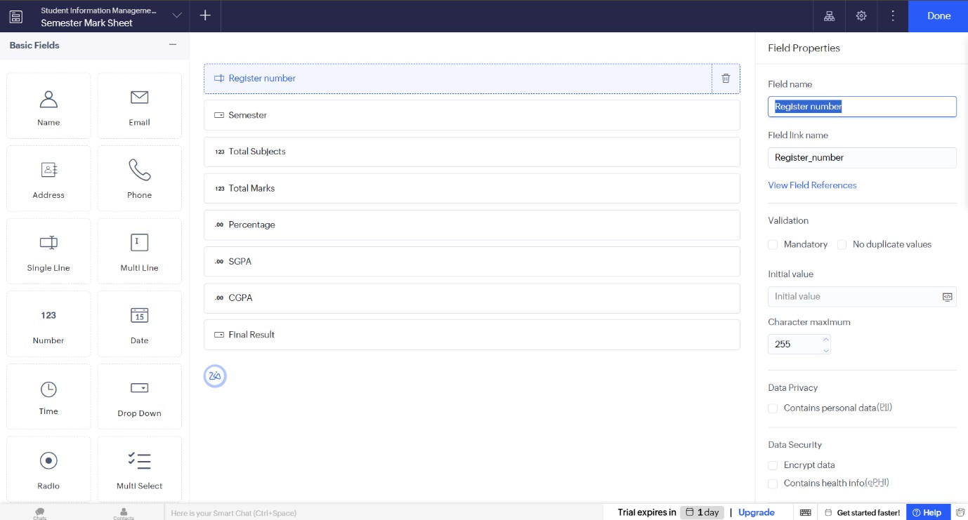

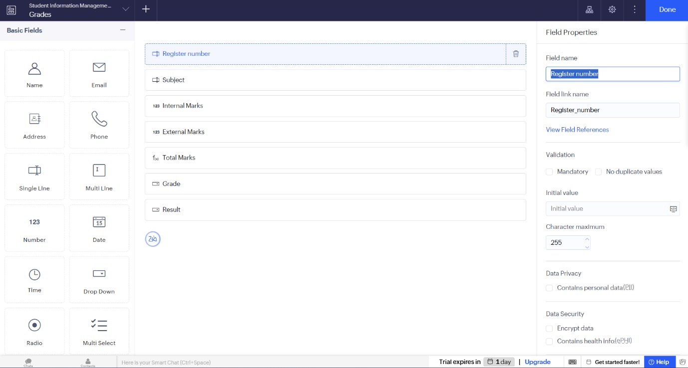

Result:
Thus, a cloud-based Student Information Management System was successfully developed using Zoho Creator to demonstrate Software as a Service (SaaS). The application stores student information, grades, attendance, progress reports, semester mark sheets, and includes a C program to display student information successfully.

LAB EXPERIMENTS-11

Create a Simple Cloud Software Application for an Online Supermarket Using a Cloud Service Provider (SaaS)

Aim:
To create a simple Online Supermarket Management System using Zoho Creator to demonstrate Software as a Service (SaaS) with customer details, item details, item classification, order details, and billing information.

Software/Tools Required:
- Zoho Creator (Cloud Platform)
- Web Browser (Google Chrome/Microsoft Edge)
- Internet Connection

Procedure:
- Log in to Zoho Creator.
- Click Create New Application.
- Name the application Online Supermarket Management System.
- Create the Customer Details form.
- Create the Item Classification form.
- Create the Order Details form.
- Create the Billing form.
- Create reports for each form.
- Create a dashboard to display customer and order details.
- Save and run the application.

Customer Details Form:

Field | Data Type
Customer Name | Single Line
Address | Multi Line
Phone Number | Phone
Email | Email

Item Classification Form:

Field | Data Type
Item Name | Single Line
Category | Drop Down
Brand | Single Line
Unit Price | Currency
Stock Quantity | Number

Category Options
  - Groceries
  - Fruits
  - Vegetables
  - Dairy
  - Beverages
  - Snacks
  - Household
  - Personal Care

Order Details Form:

Field | Data Type
Customer Name | Lookup
Item Name | Lookup
Quantity | Number
Unit Price | Lookup
Total Amount | Formula

Formula
input.Quantity * input.Unit_Price

Billing Form:

Field | Data Type
Bill Number | Auto Number
Customer Name | Lookup
Total Amount | Currency
Payment Mode | Drop Down
Order Date | Date

Payment Mode
  - Cash
  - UPI
  - Credit Card
  - Debit Card
  - Net Banking

Sample Customer Record:

Field | Value
Customer Name | Rahul Kumar
Address | Chennai
Phone Number | 9876543210
Email | rahul@gmail.com
Item | Rice 5 kg
Quantity | 2
Unit Price | ₹350
Total Amount | ₹700

OUTPUT SCREENSHOTS:
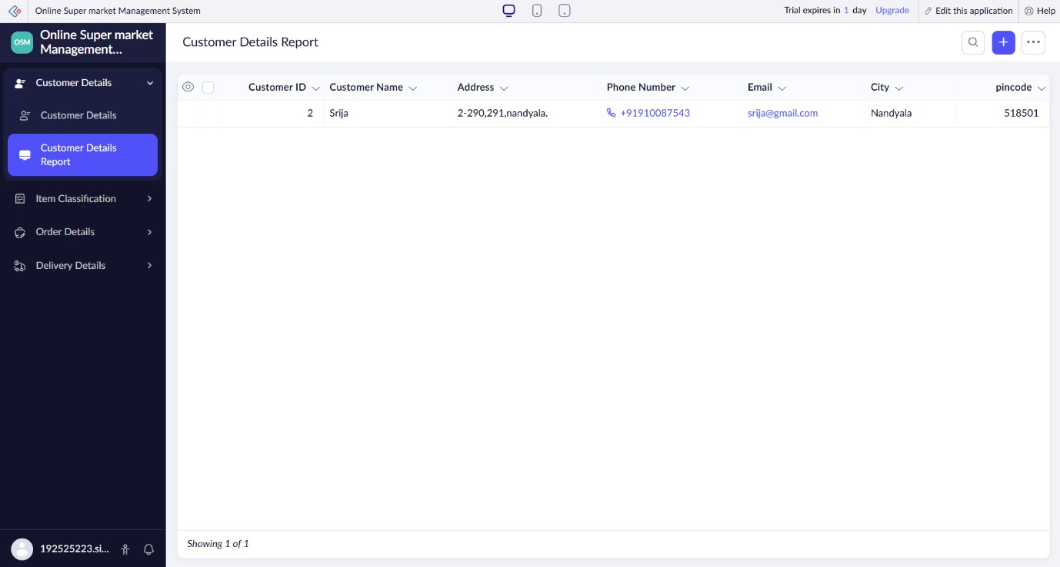
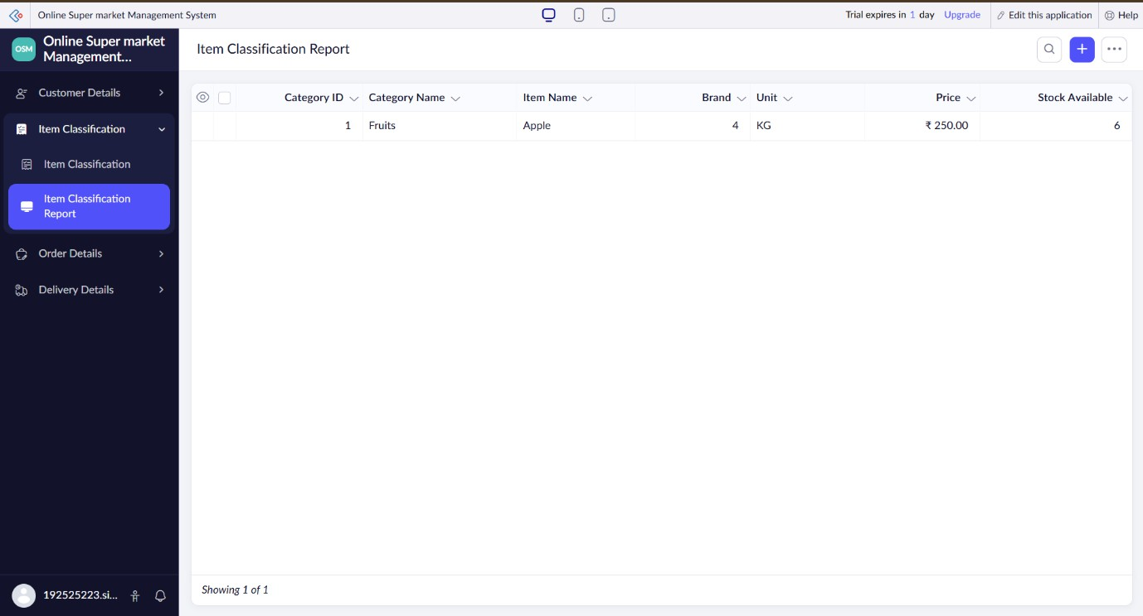

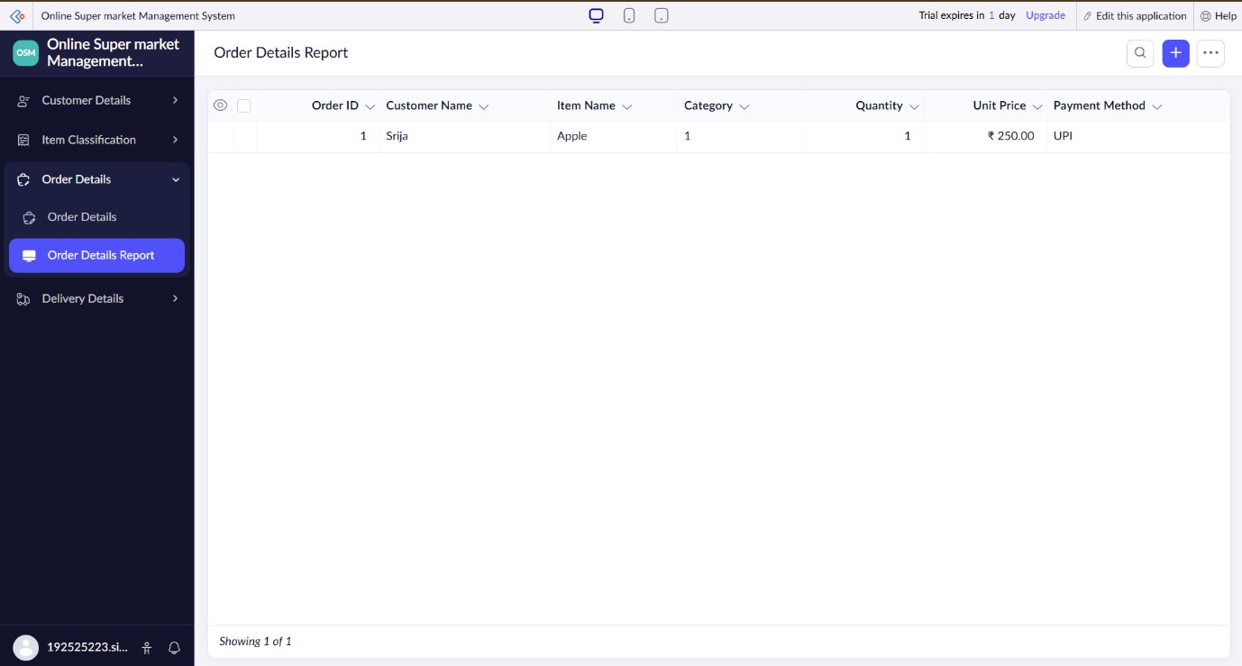
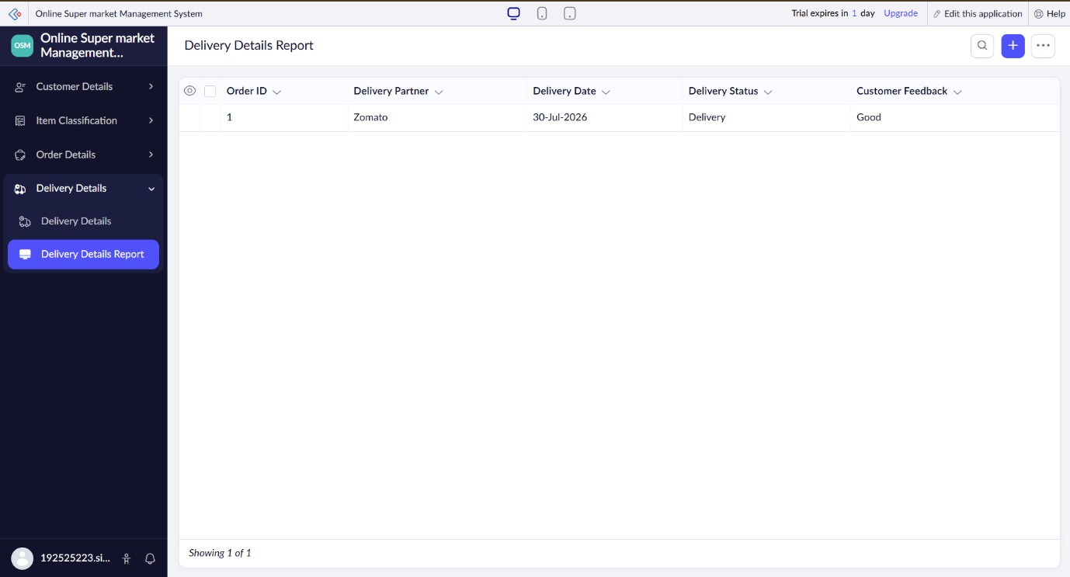

Result:
Thus, a cloud-based Online Supermarket Management System was successfully created using Zoho Creator to demonstrate Software as a Service (SaaS). The application stores customer details, item classifications, order information, and billing records, and provides reports and dashboards for efficient supermarket management.

